Api Testing

01. getCandidates

Get all candidates

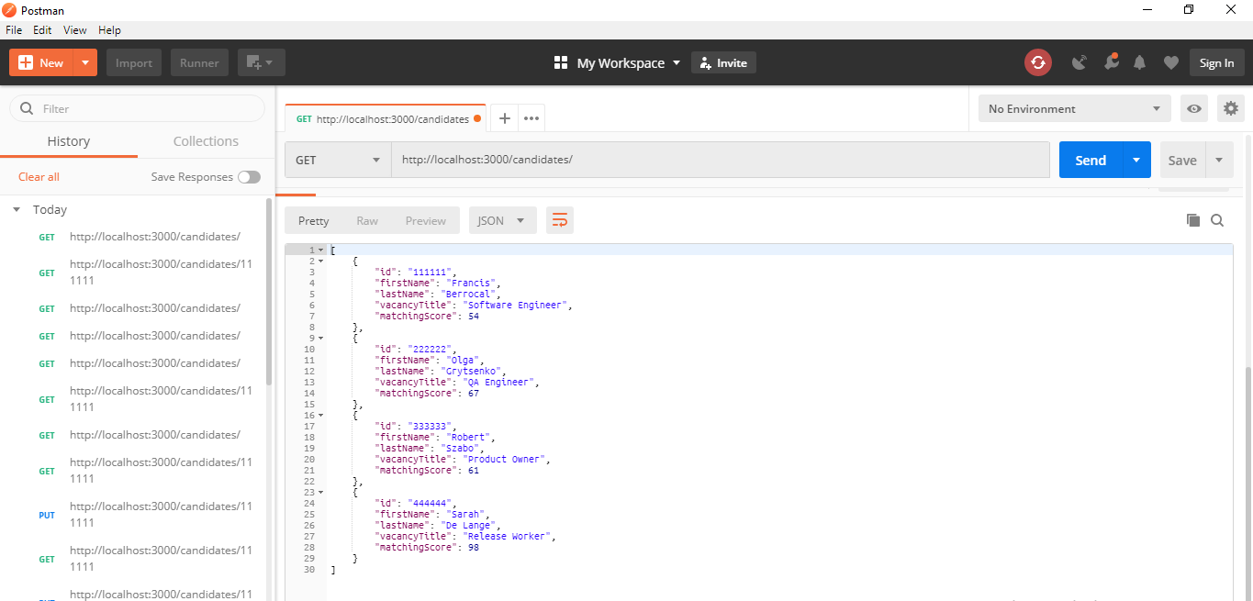

/candidates/{id}

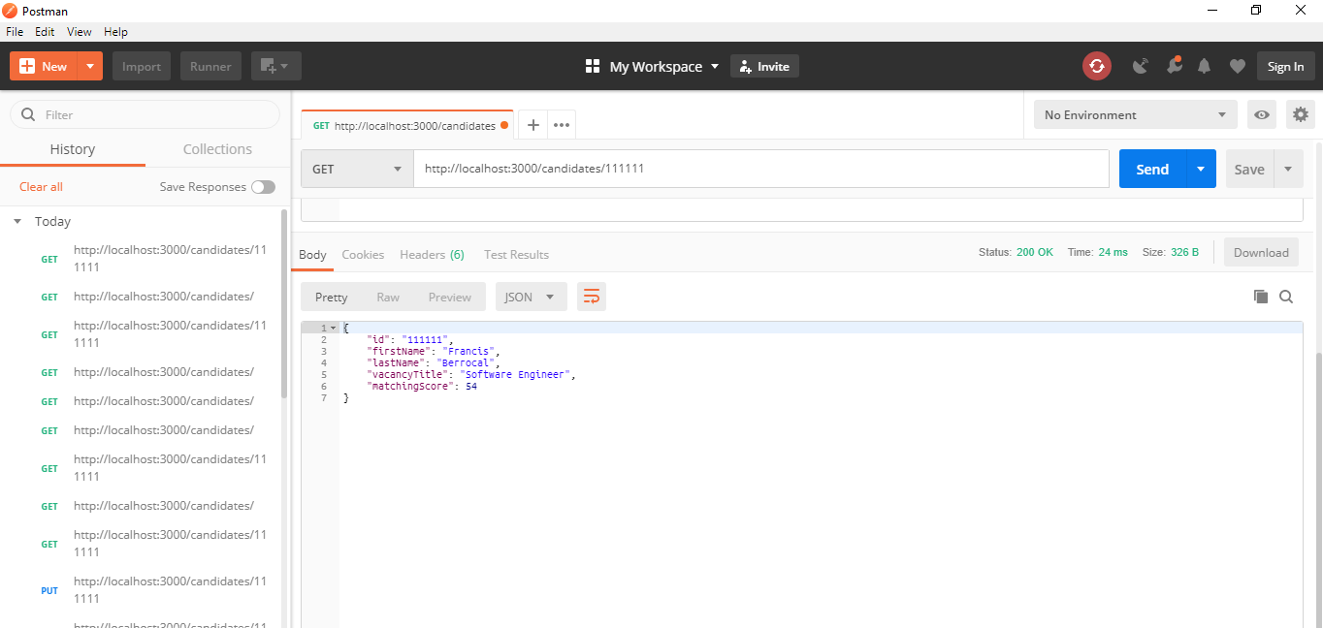

* Url does not secure any one can use the url with search via browser
* Id is a basic value any one can guess and use it – use the random token for id

02. getCandidateForId

For the PUT, UPDATE, PATCH methods need user name and password for authorization. Without user name and password cannot test the methods

Response display as Unauthorized

Refer the attachments below

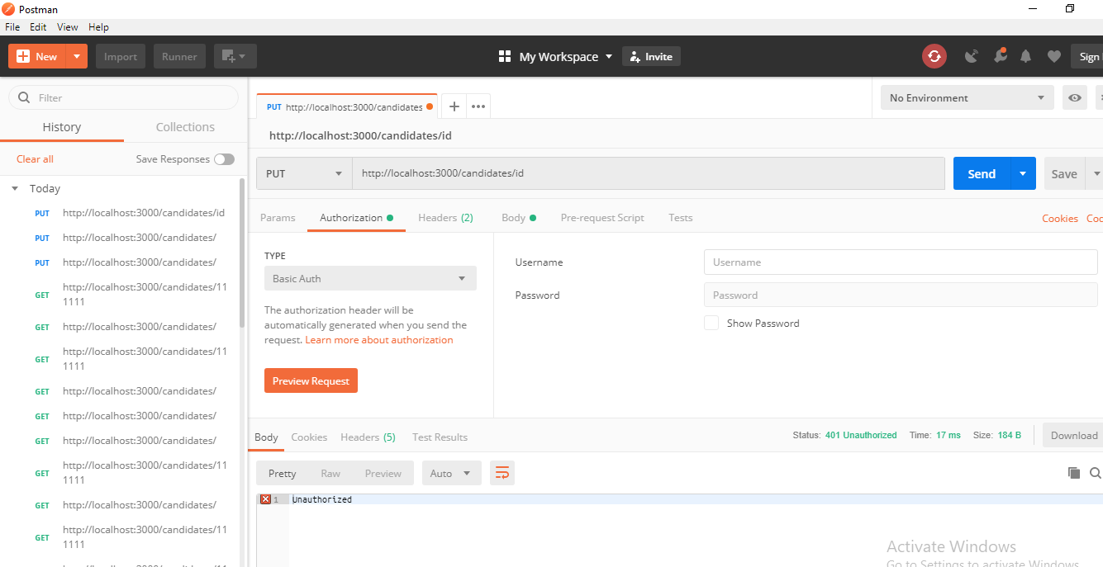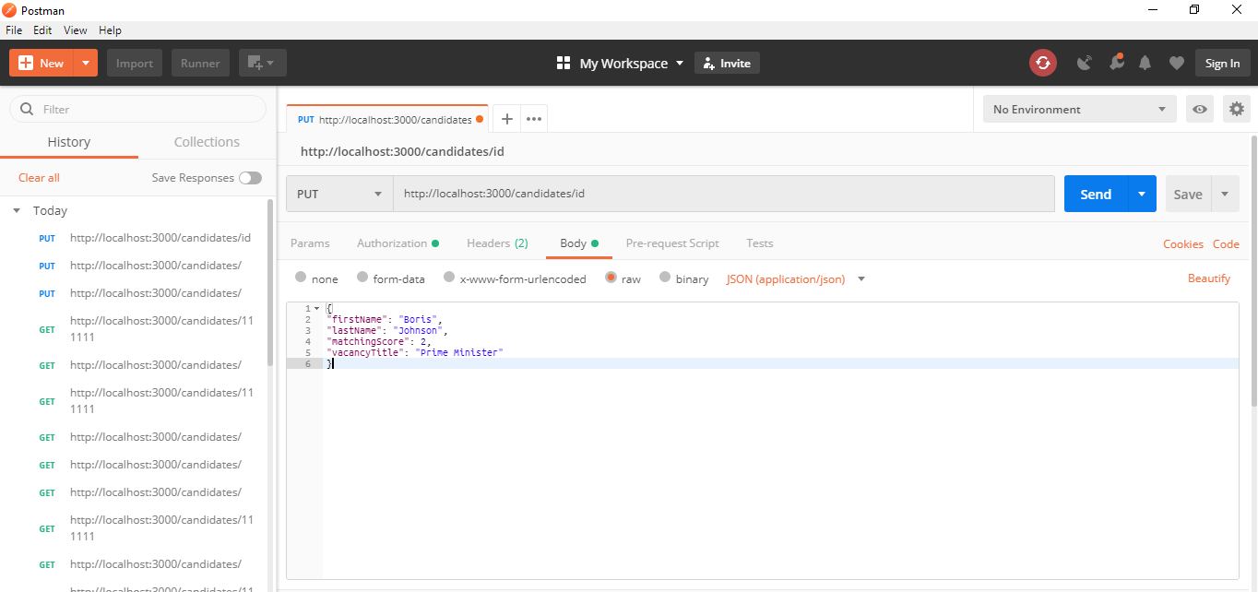

03 .deleteCandidate

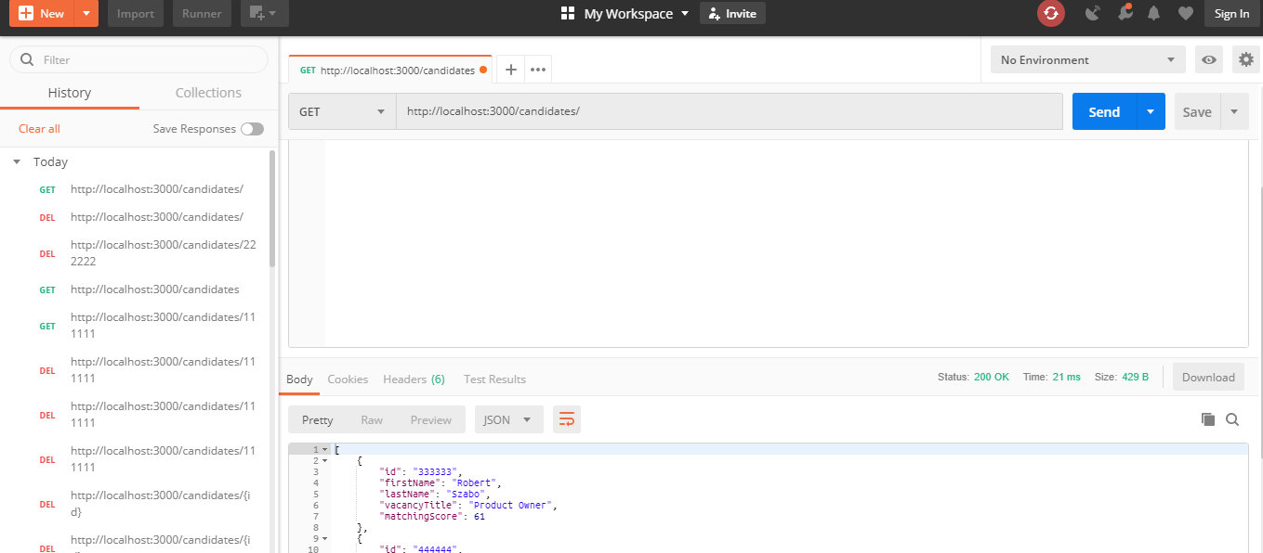

Delete Method working fine but there is no response message display when run the delete api

\*ID 111111 and 222222 records are deleted.

Pre requites

Installed Node.JS NPM and run the server.

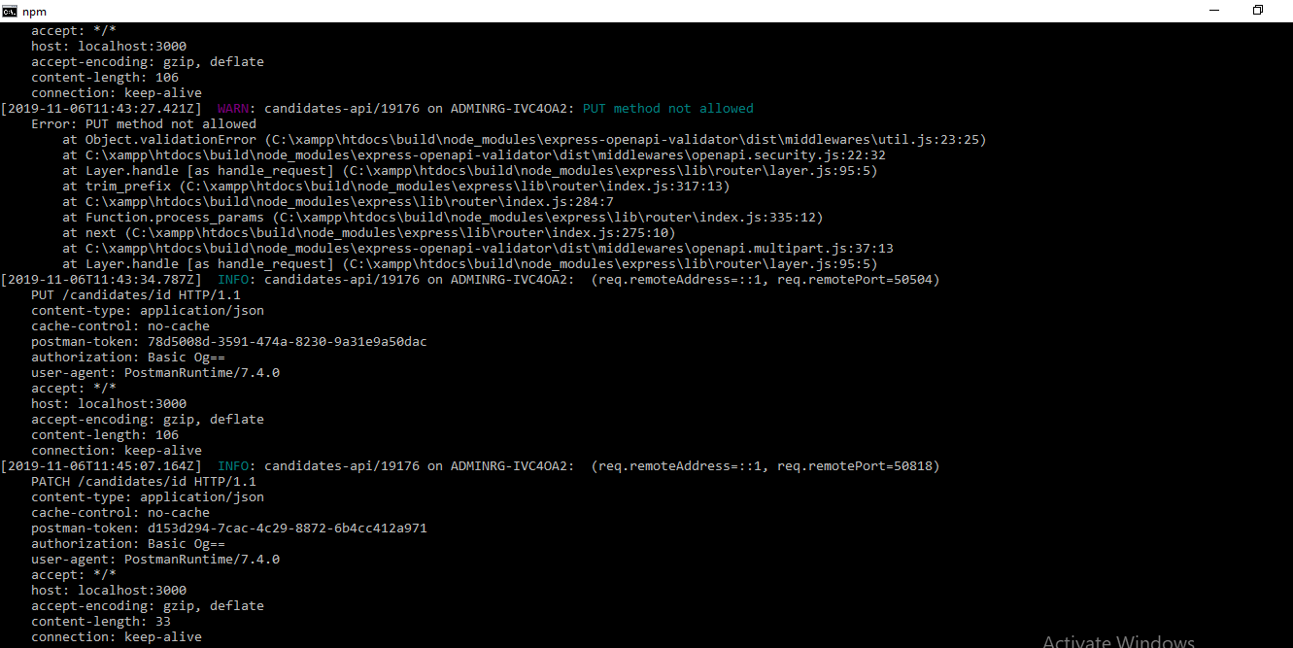

Set up Localhost server

